Automation of

Hyperlink Pasting to OpenStreet Map

Versions

Version Order Date Author Rationale

0.0 August 2018 Mary Siciliano First draft focusing on room table including populating data and Space charging.

0.1 September 2018 AnBin Hou More tables are documented including site, building, floor table.

0.2 October 2018 AnBin Hou More details on Building table are added.

1.0 October 2018 AnBin Hou Formatted and Released.

1.1 December 2018 Mary Siciliano New ‘Edit data’ view updated by Mary. Room numbering is added. Merged by AnBin

1.2 December 17, 2018 Sharan Kumar Monikanta Rajan Moved ‘Versions’ page next to ‘Contents’. Added Archibus HTTP APIs

Table of Contents

**Versions** 3

Prerequisite OpenStreet Configuration 4

Manage and Edit Excel 5

Execute the Program 6

Log File 7

# **Versions**

|  |  |  |  |
| --- | --- | --- | --- |
| Version Order | Date | Author | Rationale |
| 1.0 | May 2023 | Supanuth Amorntiyanggoon  &  Yun-Chi Hsiao | First draft focusing on basic instructions process how to update building information to OpenStreet Map |

# Prerequisite OpenStreet Configuration

Before executing a program, the config.ini must be edited to include your username and password OpenStreet Map account in order to grant the change node request process.

1. Find or create the *config.ini* file to include your username and password for the upcoming updating process.

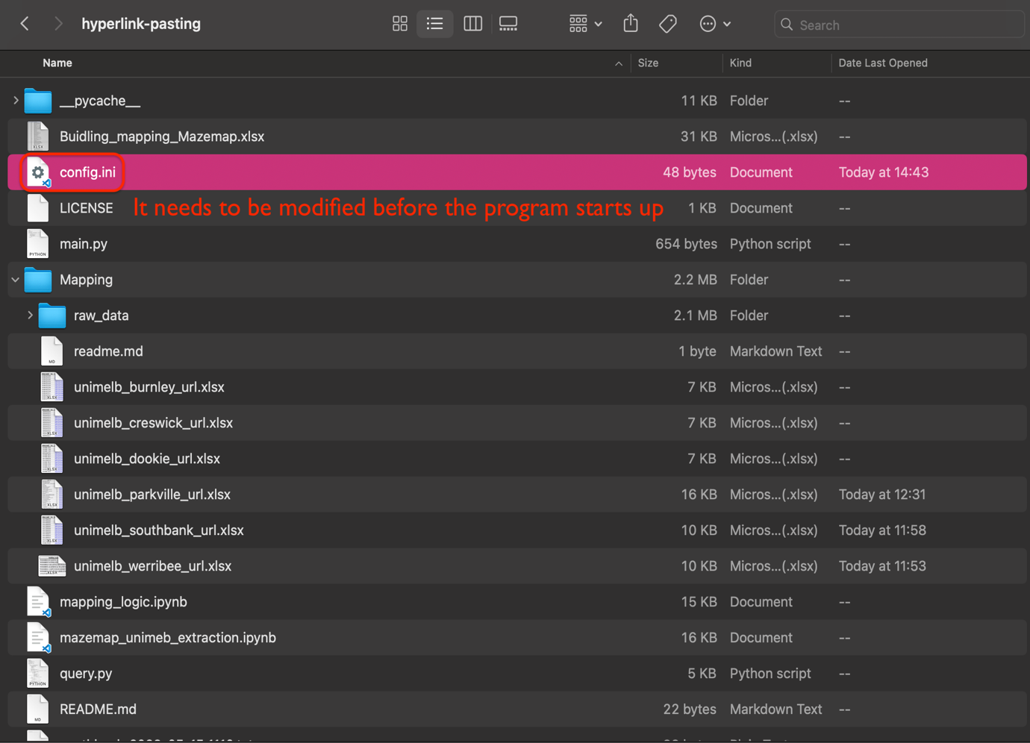

1. Type in the username and password which used to login to OpenStreet.

*For login/register:* [*https://www.openstreetmap.org/login?referer=%2F*](https://www.openstreetmap.org/login?referer=%2F)

# Manage and Edit Excel

1. **Save**. Program and data are saved in hyperlink-pasting folder. Anything in the folder is not suggested to be moved and edited, except the excel files and the configure file (*config.ini*).

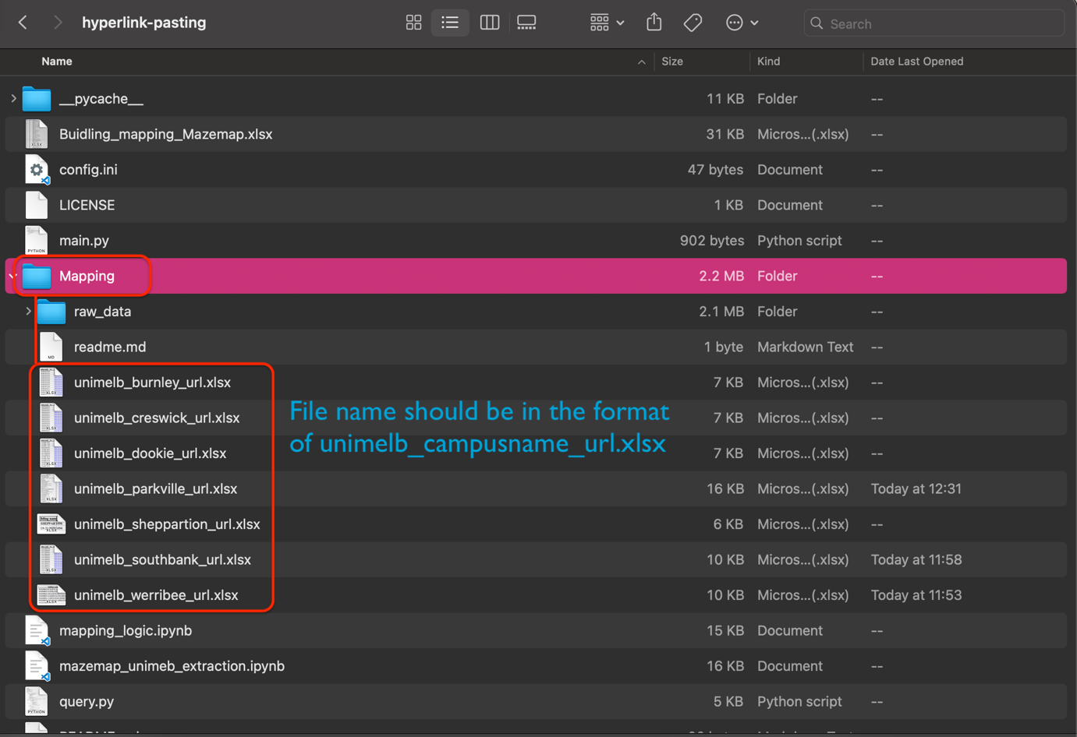

*For example (Werribee): unimelb_werribee_ulr.xlsx is stored under Mapping folder which is belonged to hyperlink-pasting folder.*

1. **Edit**. In the excel file, the building_name and building _no are mandatory. The rest of the column names are for the tags you would like to update.

*More information about OpenStreet tags:* [*https://wiki.openstreetmap.org/wiki/Tags*](https://wiki.openstreetmap.org/wiki/Tags)

# Execute the Program

To start up the program after the excel data is updated, we will type the command python3 main.py campus_name (such as parkville, werribee, southbank, etc ) in shell. Depending on the computer system, you would have different command lines to initiate the program.

1. **MacOS (Terminal)**



*Please ensure that you are entering the command when you are in the same python file folder. More information:* [*https://help.dreamhost.com/hc/en-us/articles/215465297-UNIX-commands-Working-with-directories*](https://help.dreamhost.com/hc/en-us/articles/215465297-UNIX-commands-Working-with-directories)

1. **Windows (PowerShell)**

# Log File

A log file would be generated every time the program has been executed. In the file, it displays the building name, the original information about the building and the updated information, and most importantly, whether the update is successful or not.

*If there is no error appears in the section, it means the building information has been updated. However, if there is an error, you may want to check the building name on OpenStreet Map and in the excel since the error occurs when the names are not consistent in most of time.*